Artic & Antarctica Scavenger Hunt
This activity is a fun way to practice compare/contrast skills.

Project Specifics:
- Ideal Age/Grade Level: Upper Elementary
- Project Type: Movement Based
- Targeted Literacy Skill: Reading Comprehension
- Basis: Non-Fiction/Fact Based ☒
Additional Information:

- Date: 2/28/2016
- Creator: Jade Bowden
- Program: Enrichment
- Theme: Around the World
- Estimated Cost: $ -Cheap
- Academic Level: Very Academic

Outside Sources (If Applicable): Facts from Venture Arctic (2008), PocketWatch Games, retrieved from http://www.pocketwatchgames.com/d/Lesson%201%20-%20The%20Poles.pdf

Materials Needed: printed materials (below)

Procedure:
Step 1: Set up the different “paw prints” around the building.
Step 2: Invite students to work in pairs to find the hints. The team who finds the most wins a prize.
Step 3: As a group, ask the clues to be read aloud, and then discussed.
Step 4: in pairs, ask the students to compare/contrast the two regions.

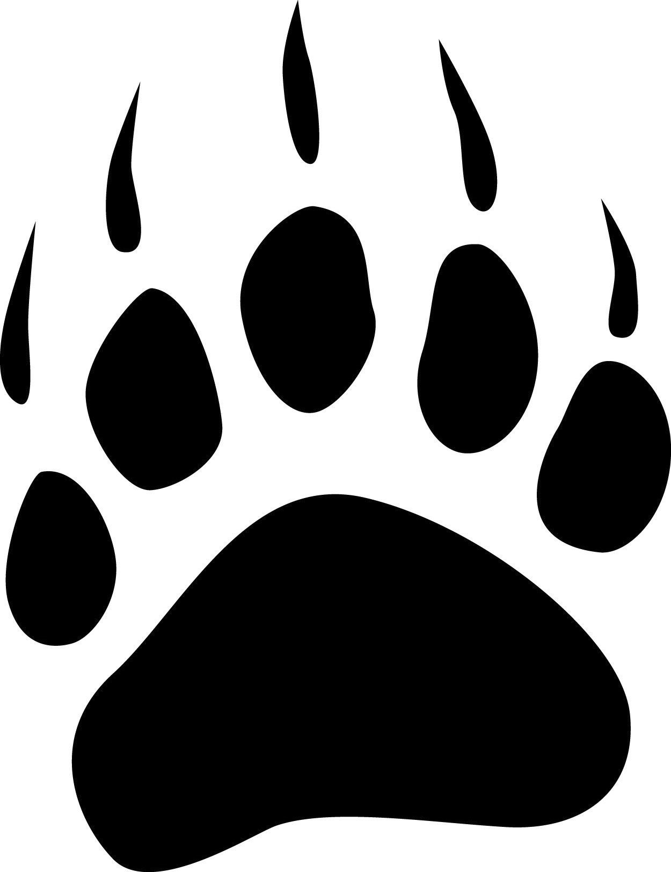
The Inuit, Inupiat and Yupik all call the Arctic their home.

The Arctic has tundra and flowering plants.

There is no land under the Artic’s frozen surface, only ocean.
The Arctic is an ocean surrounded by continents and contains the North Pole.

Polar bears live in the Arctic. The word “Arctic” actually comes from the Greek word for bear.
Winter ice sheets are getting smaller in both the Artic and Antarctica.

Portions of surrounding continents are also considered to be a part of the Arctic.

There are six seal species that live in the Arctic, all of which are different from the species that live in the Antarctic.

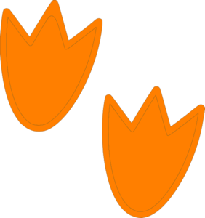

Both Arctic and Antarctica approximately six months of darkness a year, followed by six
months of light.

It is a common misconception that penguins live in the Arctic. They do inhabit Antarctica. There are 17 total penguin species, but only 4 breed in Antarctica.

Antarctica is much too harsh for permanent human settlement.

Antarctic winter begins in June.

Compare & Contrast

Artic Antarctica

Ideas of what to include: North Pole, South Pole, Winter in June, Winter in December, Desert, Dark 6 months every year, Emperor Penguins, Seals, Inuit people, flowering plants, polar bears, land-based mammals, 70% of Earth’s fresh water, melting ice sheets, no permanent settlers, continent, very little land, means “bear” in Greek, means “no bear”.

Only marine mammals (seals, whales, etc.) and birds are found in Antarctica, there are no land based animals.

Antarctica is the largest desert in the world.
About 70% of earth’s fresh water is contained in Antarctica’s ice sheets, which can be as thick as 2.8 miles.

The Antarctic (Ant= opposite) is a continent, it contains the South Pole and has land under its frozen surface.

