Brown Bag Listening & Writing Activity
- Step one: Catch-up conversationally about how you’ve been since you last saw each other. Feel free to ask questions in order to prompt the other person for more information/details.
  - Feel free to take notes or make a timeline of what the other person has been doing.
  - It is very important to listen well, because you will need these answers for the rest of the activity!
- Step two: Decide which of these three activity variations you’d like to do!
- Option #1: Using individual strips of paper, write at least 5 sentences about what the other person has been doing. Cut out each strip of paper and put them into your brown paper bag. The sentences should be cut out separately from each other.
Mary had a little lamb, but lost her last Wednesday.
Example:
Strip #1: Bob went grocery shopping last Saturday.
Strip #2: Bob has gone running every night after work for the last 3 weeks.
Strip #3: Bob visited his granddaughter in Arizona 1 month ago.
Strip #4: Bob likes Arizona because it’s hot, sunny, and full of cool rocks.
Strip #5: Bob’s granddaughter likes horses, so Bob brought her a toy pony.

- Option #2: Using individual pieces of paper, draw several pictures of what the other person has been doing. On separate strips of paper, write a caption for each picture. Put the drawings and sentence strips into your brown paper bag.

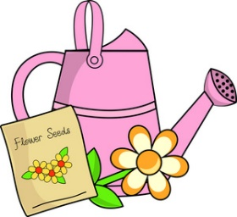
Example:
Katie has been gardening a lot this week.
Picture #1 Paper Strip #1

- Option #3: Using individual strips of paper, write at least 3 sentences about a similarity you have as tutor and student pair, or a difference between the two of you. What do you like that’s the same? What do you like that’s different? Do you do similar hobbies? How did your weekend activities compare? Have you been doing the same things? If you’d like, accompany each sentence with a picture to represent the similarity or difference.
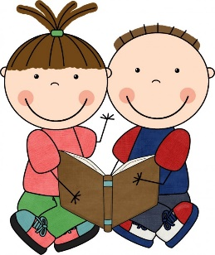

We both like to read!

Picture #1 (Similarity) Paper Strip #1
Isabella likes to read fantasy books, but Eva likes to read sci-fi novels.
Picture #2 (Difference) Paper Strip #2
- Step three:
If you completed Option #1 or Option #2: Decorate the paper bag so that it shows what your tutor or student is interested in. Feel free to use magazine cutouts, drawings, craft ideas, etc.

If you completed Option #3: Decorate the paper bag so that it shows what you both like, and what interests you have that are unique. Feel free to use magazine cutouts, drawings, craft ideas, etc.

- Step four: If you enjoyed this activity, feel free to keep adding pictures, sentences, or decorations to it throughout the year! If not, just show it off the finished product to one of the TLC staff members!
