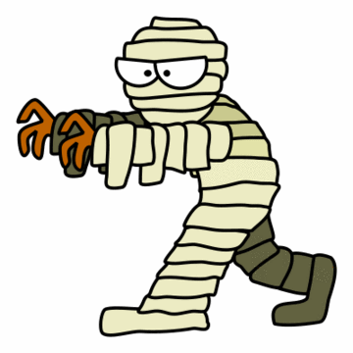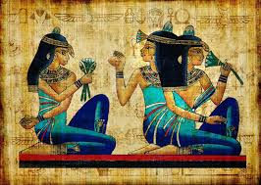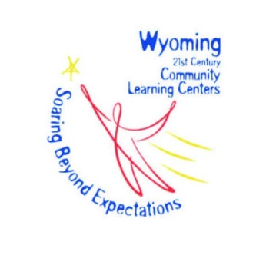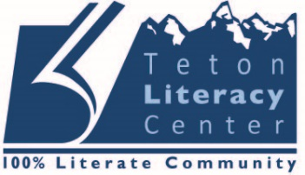

**Part 1**

* **Read a book or print-out from the backpack.**
  + Pick a book and read it independently or with a friend.
  + Write the book title, your name and date on the book wall or in your reading journal.
  + Answer one of the questions on the book wall or on your “question sheet”.

**Part 2**

(Choose 2 of these activities to complete)

* **Make your own pyramid!** 
  + Use our “Great Pyramids” template, or come up with your own design! Feel free to use Legos, clay, cardboard, plaster of Paris, paper mache, marshmallows and toothpicks, or other resources that inspire you!
* **Count like an Ancient Egyptian!** 
  + Complete the numerals worksheet problems.
  + If you’d like, play “Climb to the top of the Pyramid”.
* **Learn how to write your own “cartouche”—a.k.a. nametag:**
  + Use our hieroglyphs translator to write your name or more!

**Take it further at home!**

* + Mummify an apple! See our “Mummification” guide!
  + Make an ancient Egyptian dinner! See our “Recipes” page for details!
  + Play the game “Mehen”!
* **Check out these links:**
  + http://www.childrensuniversity.manchester.ac.uk/interactives

/history/egypt/hieroglyphs/

* + http://egypt.mrdonn.org/games.html
  + http://discoverykids.com/games/mummy-maker/

**HAVE FUN!**

Club Summer

Ancient Egypt Kit

Complete these activities to receive a stamp on your membership card!

Grades 3-8