How to Mummify an Apple
Alas, the great apple Pharaoh has died. We must help him travel to the afterlife.
1. First, we must take out his brains and internal organs – this should be done with care with an apple corer or a sharp knife – ask an adult for some help. You can chuck the brains out, but keep the other organs in special canopic jars. (See the back page.)
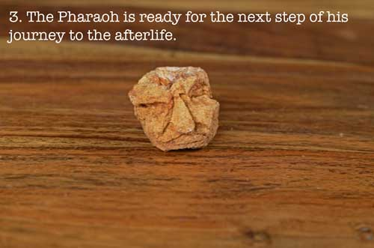
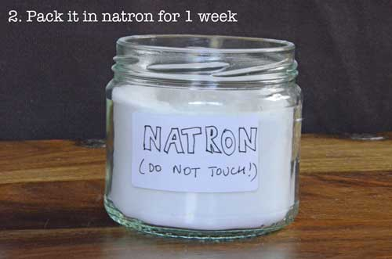
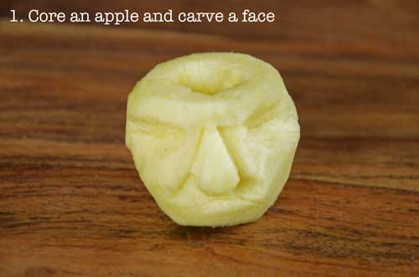
2. Next draw or carve a face in the apple.
3. Pack the Pharaoh in natron. If you don’t have any natron then a mixture of table salt and bicarbonate of soda (baking soda) will do. A ratio of 2:1 salt to baking soda works well. Store away from light.
So: 2 parts salt to 1 part baking soda.
4. In Egypt he would have been left in natron for forty days, but this mummy should be ready in about a week. Take him out of the salt mixture and gently put him to rest.

Want to mummify something else? Check out these links!
- Mummifying a chicken: http://www.mummytombs.com/mummymaking/mummychicken1.htm
- Mummify a Barbie: http://applesandjammies.blogspot.com/2009/09/how-to-mummify-barbie.html
- Mummify an online mummy!: http://games.talkingpyramids.com/the-mummy-maker/

Do-It- Yourself (DIY) Canopic Jars
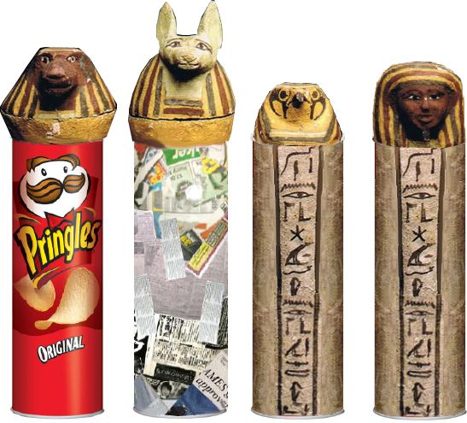
Materials:
- Newspapers
- Pringles can
- Masking Tape
- Paper Mache Paste (See Instructions.)
- Acrylic Paint or Tempera Paint
- Brushes

Alternatives to Pringles cans: Use baby food jars, plastic containers, soda or water bottles, or ice cream cartons.

Preparation:
- You need a Pringles can for each “organ”.
- Take the lids off and put aside.
- Prepare Paper Mache mix in a bowl.
- Cut strips of newspapers to put on the outside of the Pringles cans and over the “heads”.
- Make the “heads” by attaching newspaper to the lids with masking tape. Form the shape you want.
- Paper mache the can, being careful not to seal the head on. (You should be able to open the “jar.”)
- Wait for the paper mache to dry for at least 24 hours.
- Paint your jar and the head!

Feeling daring? Check out these links!
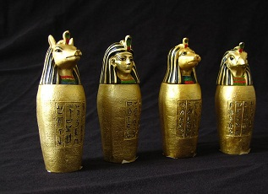
- http://www.klairedelys.com/2013/03/26/diy-canopic-jar/
- http://www.wikihow.com/Design-and-Make-a-Canopic-Jar

