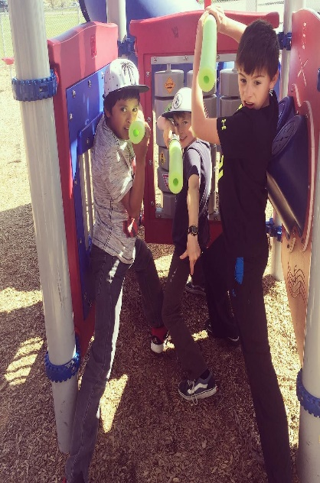
Lightsaber How-To
Materials:
- Pool Noodle (Buy at the Dollar Tree)
- Duct Tape
- Electrical Tape
- Tape Measure
- Marker
- Bread Knife
- Scissors

Directions:
- Measure the length of pool noodle and mark center with the marker.
- Using the bread knife, cut pool noodle in half.
- On one end of the pool noodle, wrap duct tape around once.
- Wrap duct tape around 3 more times, going up the pool noodle.
- OPTION #1: Darth Vadar Style
  - Wrap two rows of electrical tape right above the top of the duct tape wrap.
  - About 1″ under the first row of electrical tape, wrap two more rows
  - Cut seven 3″ pieces of electrical tape and tape them vertically under the second row of duct tape, about an inch apart from each other.
- OPTION #2: Skywalker Style
  - Wrap two rows of electrical tape right above the top of the duct tape wrap.
  - Wrap 3 more rows of electrical tape under the first row of electrical tape spacing each row about 1/2″.

Star Wars Games to Play at Home
- Sight Word SMASH:
  - Using white or colorful sheets of paper, write out words that you want your child(ren) or students to practice.
  - Tape up the papers to a wall or to the floor.
  - If working in a group setting, ask your children/students to compete against each other in teams. Have one player from each team go at a time.
  - Shout out a word. Whoever hits the word first with their lightsaber gets a point. The first team to get 21 points wins. (Teammates cannot point to the answer, but may give verbal clues.)
  - For a twist on this, practice learning vocabulary definitions with your lightsaber! Tape up words to the wall, and then read aloud their definitions.
  - If playing with just one child, time yourselves to see how quickly you can complete these challenges.
- Re-enact scenes:
  - Pick a scene from one of the films.
  - Ask your students or children to write down the dialogue and battle movements of approximately 1 minute of the chosen scene.
  - Re-enact the scene. For added fun, film it!
- Play online:
  - http://www.zoodles.com/free-online-kids-games/star-wars
  - http://www.kidsastronomy.com/starwars/fallingvga.html
  - http://games.disney.co.uk/star-wars-rebels/star-wars-arcade
  - http://www.starwars.com/games-apps
- Party Games:
  - As a group, see how long you can keep a balloon in the air if you ONLY use your lightsaber to hit it.
  - See how many bubbles you can pop with your lightsaber in 1 minute.
  - Host a fencing tournament! Remember, hits only count if they are on your torso!

