November Family Newsletter
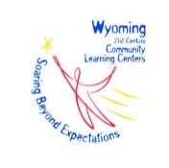
Teton Literacy Center
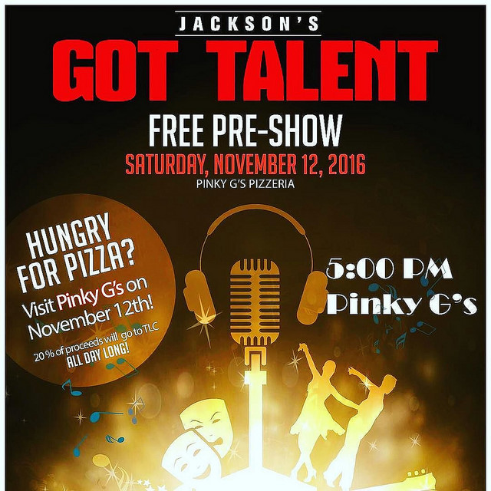

Upcoming Events

Jackson’s got talent
Saturday November 12th
Join us at Pink Garter for the most talented fundraiser of the year! Voting is going on now. https://jacksonsgottalent.org/

Family Literacy Night
November 17th 5:30-7pm
Mark your calendars for a brand new family literacy event! We will be featuring all kinds of GAMES! Families will race around their game board and vie to complete a wide variety of games.

Applications Accepted for Winter Club Session
November 14th-December 1st
Applications are online www.tetonliteracy.org and in our office. Families are notified of acceptance on December 8th.

No Programs
November 21st - 25th
There are no Teton Literacy programs the week of Thanksgiving. Programs resume Monday November 28th.

1715 High School Rd. Jackson, WY 83002 Find us on
www.tetonliteracy.org T: 307-733-9242
Dear Families,
With various holiday vacations coming up, consider checking out our blog on the Teton Literacy website http://www.tetonliteracy.org/blog for some ideas for family-friendly activities to do at home and on-the-go. We hope you can find some ideas to enrich your kids’ time! For instance, a couple weeks ago we posted a STEAM activity that we completed in our Inventor’s Workshop. Interested? Check it out here!
To let us know how to best support your needs, feel free to give us some feedback through this very short 5-question survey. We appreciate your time.
Happy Autumn!
Best, TLC Staff

Parent-teacher Conferences

Supporting growth and learning
Parent-Teacher conferences were November 7th-11th! We hope you found them useful. We know teachers are appreciative of the opportunity to connect with you, so thanks for taking the time to participate. It’s a crucial opportunity to support your child in their education.
Education Nation offers a number of tips towards successful parent-teacher conferences: the first and most important step is your involvement.
- Meeting with your child’s teacher sends the message to your child that education is important and that you care.

- Building a partnership with your child’s teacher is a great way for you to support your child and each other.
- Talk with your spouse, partner or any other guardians for their insights.
- Conferences are a good place to discuss a holistic view on your child’s academic progress, but also social and emotional health.
- You may meet or visit rooms where your child spends the majority of their day. This is a good time for you to experience what your child’s daily environment is like, in addition to talking with his teacher one-to-one.
- Bring up anything that is happening at home that could affect your child’s learning or participation in class.
- Involve your child in the conversation, before and after the conference itself. What does he think he is doing well and why? Where does she think she can improve, and how? Often kids are very aware of their own growth.
Keep Teton Literacy staff in the loop if there are literacy skills your son or daughter can use support in. If they are in afterschool club, we can help direct students towards certain homework during homework time at the beginning of Teton Literacy club. If they are in tutoring, let us know teacher feedback on their reading and writing in the classroom.
Interested in more information? Check out this parent toolkit with many resources at http://www.parenttoolkit.com/

Call for support
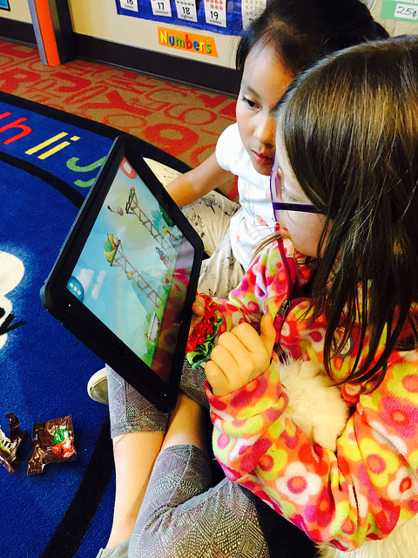

Parent Participation Week
December 12th - 15th
Join us for the last 15 minutes of your child’s club or tutoring session! Students will be proudly showing you what they have worked on and learned this session!

Winter Vacation
December 23rd-January 6th
Programs resume Monday January 9th. This is also the first day of our winter club session.

Winter Club Session- More Info about the Next Application Period
Information about our winter club choices is available starting November 14th week on our website at www.tetonliteracy.org and at our office! Take a look at the options, look at your family’s schedule, and talk with your child about their favorite topics.
In order to allow enough time for interested families to apply, we offer an application period from November 14th until December 1st. Submit your application online or at our office. We will notify families of acceptance on December 8th. Questions? Check out our website for more info or give us a call.

We are excited that the 2016 Jackson’s Got Talent event on November 12th at the Pink Garter Theater is benefiting Teton Literacy Center! Vote online at www.jacksonsgottalent.org
Do you or does anyone in your family want to buy a ticket to the show? Tickets are on sale at www.jacksonsgottalent.org/tickets . It promises to be a talent-filled night for an awesome cause! Want to get involved that night in a more relaxed way? Come see the free show at Pinky G’s at 5pm and enjoy pizza. Pinky G’s will donate 20% of sales on November 12th to support Teton Literacy.

