Reader’s Theater: Norse Eclipse Legend

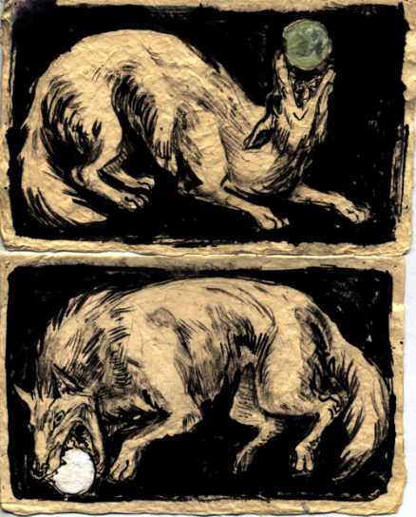
Characters:

- The Narrator
- Skoll (Wolf)
- Hati (Wolf)
- Sun
- Moon
- People of Earth

Setting:

- This story takes place in the sky.

NARRATOR: Once, long ago, there were two wolves that were very greedy.

SKOLL: Brother, I want to eat the sun! It looks so big. It will fill my belly with warmth.

HATI: Brother, I want to eat the moon! It looks so tasty and refreshing.

NARRATOR: The Sun and Moon were worried about the wolves, but stayed on their normal paths anyway.

SUN: I am scared of those wolves, Moon. I don’t trust them at all.

MOON: We must not let them keep us from following our path, Sun. They can’t catch us.

NARRATOR: One day, the wolves decided to chase down the Sun and the Moon.

SKOLL: Run as fast as you can, brother! We will have a feast of the Sun and the Moon.

SUN: Help us, help us!

MOON: I think Hati has got me, Sun!

NARRATOR: The wolves ran and ran as fast as they could. Skoll caught the Sun with his big sharp teeth.

SUN: Ouch! Moon, this wolf is holding me down.

NARRATOR: Hati caught the Moon, dragging him on top of the Sun.

MOON: We are done for, Sun.

HATI: Hush, Moon! You will be our dinner once I’ve dragged you into a nice pile. We will eat you piece by piece for supper.

SKOLL: No one will see you again, Sun. You’re all ours.

NARRATOR: The people of Earth became scared as the sky grew dark as night.

PEOPLE OF EARTH: What is happening? Help us! Help us! We are scared of this sudden darkness.

NARRATOR: The people of Earth cried so loudly that the two wolves became frightened and decided to run away.

HATI: Run, brother! Someone is coming to punish us for trying to eat the Sun and Moon!

MOON: Brother! We are free.

NARRATOR: Moon dragged himself up slowly and then helped Sun up, too.

SUN: Thank goodness the people on Earth made all that noise and scared the evil wolves away.

PEOPLE OF EARTH: The sun has returned! Our cries have frightened away the darkness!

NARRATOR: Now the people of Earth live happily as the Sun and Moon journey through the sky. They know that they must make a lot of noise to scare away Skoll and Hati if they ever try to eat the Sun and the Moon again.

