Spin Art
Materials (what you need):
This is What It Looks Like:

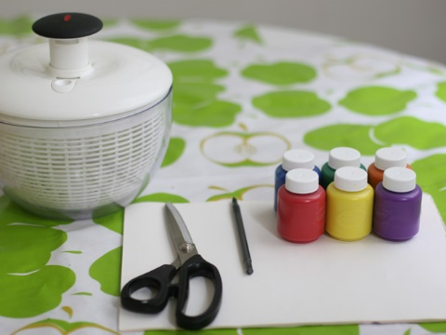

Procedure (how to make it):

#1: Cut out shape.

#2: Put shape into spinner.

#3: Choose 1, 2, or 3 colors of paint to add. Add paint.

#4: Close spinner.

#5: Hold spinner closed, and spin!

#6: Take card out. Put on newspaper to dry

#7: It’s the next person’s turn. Take turns.

