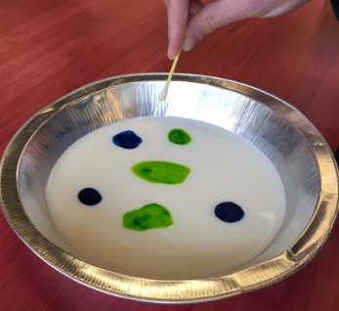
Milk Experiment
Materials:  You Need… | I Can Describe It…  Descriptive Word | It looks like…  Sketch it
Milk
Plate
Food Coloring
Q-Tip
Dish Soap

Procedure- What to do…
Remember- be nice, take turns, share, help one another, ask for help, don’t make a mess, and don’t use too many materials. Have fun =).

#1: Pour a little milk in the bottom of the plate. Only a little milk!

#2: Add 6 drops of food coloring. Use 2 or 3 different colors.

#3: Touch the Q-Tip to the dish soap.

#4: Now touch the Q-tip to the middle of the milk plate.

What happens?
Draw and write your answer.
______________________________
______________________________
______________________________

#5: Put your card on top of the milk to color it.

