Feb. Family Newsletter
Teton Literacy Center
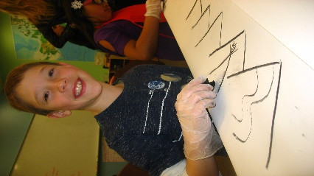

Upcoming Events

March 16-19
Last week of winter clubs.

March 12

Around the World Family Night! 5:30-7pm
Come to TLC and travel the world! Students in our Around the World clubs and the fun staff at TLC, will turn our office into different countries from around the world.
You and your family will receive a passport to travel and experience different cultures. Try new foods, games and crafts and cool activities.
Appropriate for all ages! The entire community is invited so bring your friends!

April 13th-may 28th
Spring clubs session!

Donations Requested
We are looking for Go Pros. If you have an old go pro you don’t use much, donate it to TLC! Movie making is a great way to practice story telling!

-

1715 High School Rd. Jackson, WY 83002
www.tetonliteracy.org T: 307-733-9242 Check us out on
Dear Families,
I have to tell you that your kids continue to impress me every single day! Your students are making some great connections in class between the projects we are working on to their own background knowledge, work they have done at school, and books they have read. I also have two boys in class that can make a logical connection between everything we do and Minecraft, which is pretty impressive. There is a lot of fun stuff happening here in the coming months so make sure to check out our website www.tetonliteracy.org for the most up to date information.
Sincerely,
Kristin Livingstone and the entire TLC staff.

A literacy Rich Environment?
At TLC we strive to create a literacy rich environment. What does that mean? Well, that means that we want reading, writing, talking and listening to be a natural part of the day.
A literacy rich environment is important at school and at TLC, but it is equally important in your home! Literacy development is a continuous process and parents are their child’s first teacher. So how can you build a literacy rich home environment?
- Establish a regular time and place for reading, or read alouds
- Keep lots of reading materials where your kids can reach- books, newspapers, magazines and flyers for events.
- Have frequent conversations with each child individually as well as a whole family
- Play games that reinforce literacy such as puzzles, trivial pursuit, scrabble, concentration, candy land, etc.
- Balance screen time with other learning or active activities.
- Have writing materials in an easily reachable place.
- Leave notes and messages for each other around the house

Screen Time
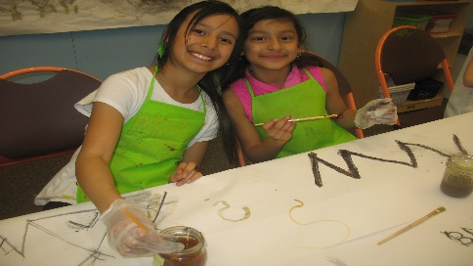

In the Community

Saturday, Feb. 7th
Family Valentine-Making Party at Teton county library 10am!
- Practice writing skills with an authentic purpose!

Sunday, Feb. 8th
JH Art Fest at Teton County Fair Building!
- Check out great works of art and get inspired for some new weekend activities!

Friday Feb. 13th
Stargazing at Center for the arts at 7pm.
- Look through the giant dobsonian telescope and get some great conversations started!

Friday Feb. 13th
Heartbeats Valentine’s Dance Party in the Center for the Arts lobby.
- Did you know our own Zach Shepard, sings with the Cathedral voices choir? Experience Jazz music and songs from the 70’s-90s with your family!

But I really like minecraft!
I love surfing the internet, watching films and even some bad T.V. occasionally. A few month ago I even wrote about great apps and games that your kids could play. But, just like anything there is a balance. The American Academy of Pediatrics guidelines recommend less than two hours daily of screen time- including TV, internet and various smart devices.
The Mayo clinic posted an article online about the effects of too much screen time. They include obesity, irregular sleep, behavioral problems and impaired academic performance.
The good thing is, there are so many other fun things to do! One of my favorite ideas for reducing screen time is the “activity jar.”
You and your kids sit down one night and write ideas of cool things to do on pieces of scratch paper and put them in a jar. Whenever a kid is feeling bored or has been glued to their phone for what seems like hours, have them choose an activity from the jar. Some families have their kids choose one activity a day. Some families pull an activity only when their bored. Each family’s use of the activity jar will be a little different.
Here are some fun ideas to get you started:
- Read a book, then act it out
- Build a fort
- Make your own board game
- Learn about a real king or queen
- Design a rocket using materials in the recycle bin
- Memorize three riddles and stump someone
- Paint a picture and write a short story about it
- Take photos and design a photo book
- Make a movie with your friends
- Build a snowman or snowalien
- See how many snow angels you can fit in your front yard
- Memorize your favorite song lyrics
- Make up a dance to your favorite song

Spring club and summer info coming soon!
This season’s clubs ends the week of March 16th- March 19th. I am surveying the students to see what they are most interested to learn about in spring. Information will be available online and handed out to families soon!
It is snowing in February, so naturally I am busy planning out summer camps! I am so excited about what is coming together for summer 2015. Information will be available online and handed out in the next month!

