October Family Newsletter
Teton Literacy Center
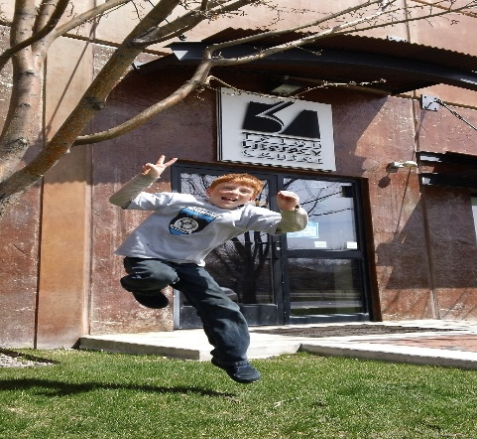

Upcoming Events

November 20

Music and Literacy Family Event!
Come to TLC with your entire family to learn about the connections between Music and Literacy!
Enjoy fun workshops, play music, and find great books!

Student Quotes of the month
“Miss! I heard that song (Taylor Swift- Shake it Off) on the radio today. I really like that song now.”
- Isaac, 3rd grade boy, in Music, Lyrics and Poetry
“Buuuuuuurrrrp!”
- Jace, 3rd grade boy, winner of the burping contest in Grossology

“Oh, I am a dancer. That is why I am wearing this mask”
- Blake, 3rd grade girl undercover, in Spy Club.

-

1715 High School Rd. Jackson, WY 83002
www.tetonliteracy.org T: 307-733-9242 Check us out on
Dear Families,
We are so excited that you chose TLC to be a part of your child’s afterschool enrichment. We are off to a great start this month and the kids are beginning to really dive into the material they are studying.
Each month I will be writing to all of our families about a different topic that relates to your child’s growth and development. Today I hope to give you a little more insight into the ideas and curriculum behind our afterschool clubs.
Sincerely,
Kristin Livingstone and the entire TLC staff.

What is Text?
At TLC we use an expanded version of the definition of text. As adults we use literacy skills every day, not just when reading books. We read online, we read recipes, we interpret symbols, phrases and conversations and we write notes, lists, memories and more.
At TLC we want students to engage in more than just reading and writing “for school.” We want students to engage in authentic literacy experiences that they will encounter for the rest of their lives. For example, our students in our Music, Lyrics and Poetry classes have been reading song lyrics, watching music videos and then discussing the messages presented in the text and video.
As a club we take 15-20 minutes to read the lyrics and interpret the meaning. Then we take a look at the music video and compare it to our interpretation of the song. Students are completely engaged in interpreting words, making connections between different texts and having thoughtful conversations about something they care about.

What about Projects?
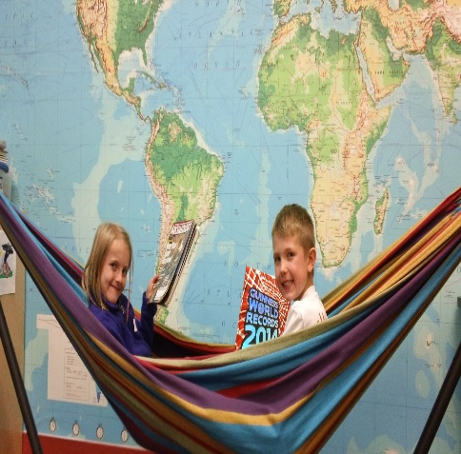

In the Community

Author talk at the Schools
Author, Jack Gantos, spoke at some of the local elementary schools as well as the library last week.
Try reading a Jack Gantos book with your child this month!
Here are some of his popular series:
The Joey Pigza Series
The Norvelt Books
The Jack Henry Adventures
The Rotten Ralph Readers
And for older readers:
Hole in My Life, Desire Lines and Rumbaughs

Family book clubs
TLC and Teton County Library have partnered together to offer family book clubs for grades 4-12th. These book clubs are a low commitment way for you and your child to share some quality time together.
Both you and your child read the same book. Together or on your own. You meet once a month with other families in the same grade and share your thoughts and opinions on the book.
This is not only fun, but if you don’t finish the book, no big deal. Talk about what you did read. Can’t make it one month? That is okay too. Fun and no commitment necessary.
Call TLC for more details!

Project based learning
At TLC we use project based learning. Learning skills is important, but equally important is learning to apply them in authentic life opportunities. Projects, both small and large, help students apply what they have learned in a larger context and gives their learning meaning.
As an example, students in our Lights, Camera, Action club are creating their own plays! Students are taking classic tales and putting a Halloween spin on them. The three little pigs is now the Three Little Vampires. We will be videotaping these plays and showing them to the preschool classes at TLC!
Our students know that they aren’t writing plays just to be read by me, the teacher, but for a real audience. This helps them really think about their audience when rewriting their script. I heard one students saying, “That is way too scary for a 4 year old. We don’t want them to have nightmares.” Success!! Students are applying their understanding of audience in their writing.
Soon we will be creating costumes and sets. If you walk into our club on one of these days, you might not see a lot of reading and writing going on, but, literacy is there! Students are thinking, communicating and problem solving. Students are forced to think about setting and characters in detail. Would a vampire’s house be made of wood? That could kill them!
Projects are such a great way to ensure that students are engaged in their learning. They know there is a real audience and purpose in their movie and it matters that all the details are correct. They are putting so much thought into these projects, and that is exactly what we want for our students. We want them to be thinkers.

What about 2015?

Continuing clubs
We sincerely hope that all of our current students will continue with us for the entire school year. As you know the current clubs will end on December 18th. But don’t worry we will have new clubs in January!
I know that some parents are already thinking about what 2015 will look like. We will be releasing the new club schedule the first week of December. Keep an eye out for it.
Our Winter Session of clubs will run from January 5th –March 26th

